192524226 – P Rahul Sai

- ANALYSIS DEVELOPMENT AND VERICATION OF 8 BIT & 16 BIT ARITHMETIC OPERATIONS USING ASSEMBLY LANGUAGE PROGRAM

OBJECTIVES
- To develop and verify assembly language programs for performing 8-bit addition and subtraction using the 8085 microprocessor and observe the results stored in memory.
- To develop and verify assembly language programs for performing 16-bit addition and subtraction using the 8085 microprocessor and analyze the results obtained.
- To develop and verify assembly language programs for performing 8-bit multiplication and division using the 8085 microprocessor and check the accuracy of the results.
- To develop and verify assembly language programs for performing 16-bit multiplication and division using the 8085 microprocessor and validate the results obtained through memory locations.

COMPONENTS REQUIRED
- 8085 Simulator OR 8085 Microprocessor

PROCEDURE
- Open the 8085 microprocessor simulator software.
- Write and enter the assembly language programs for 8-bit and 16-bit
addition, subtraction, multiplication, and division.
- Store the input values in the specified memory locations.
- Execute the programs and observe the arithmetic operations performed by the microprocessor.
- Check the results stored in the specified memory locations.
- Verify the results by comparing them with the expected mathematical outputs.

- verify assembly language programs for performing 8-bit addition and subtraction using the 8085 microprocessor and observe the results stored in memory.

8 BIT ADDITION :
MVI C 00h
LDA 4200h
MOV B A
LDA 4201h
ADD B
JNC SKIP
INR C
SKIP: STA 4202h
MOV A C
STA 4203h
HLT

OUTPUT

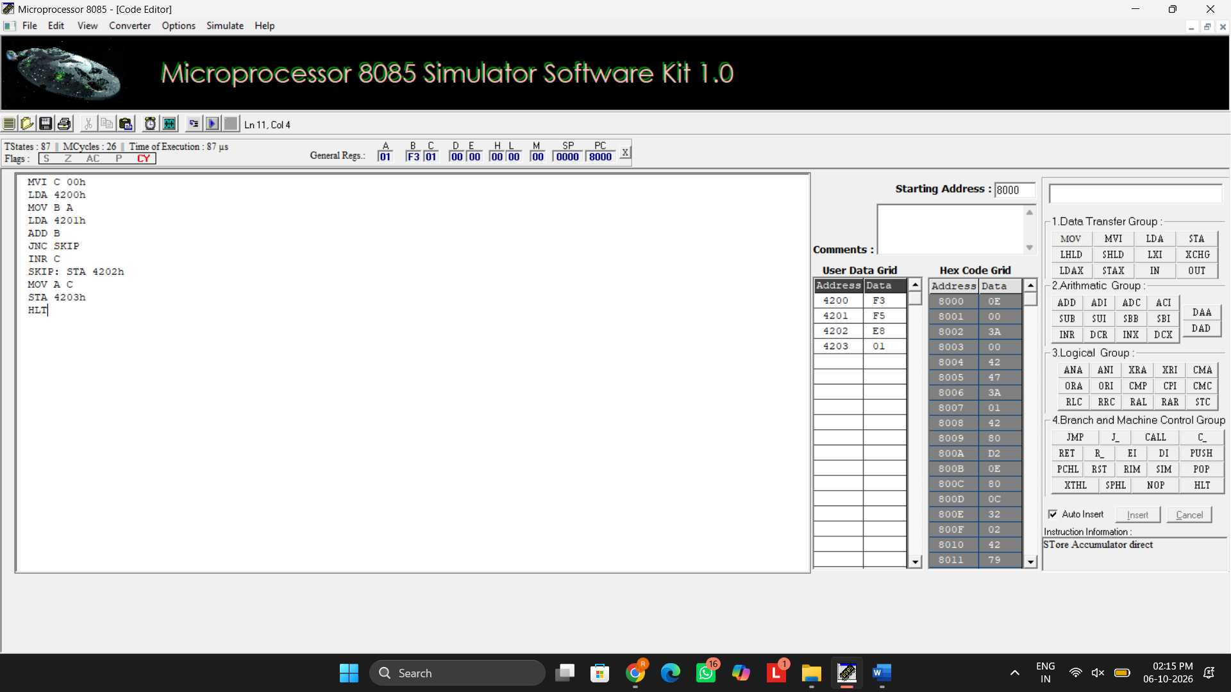
8 BIT SUBRACTION :
MVI C 00h
LDA 4201h
MOV B A
LDA 4200h
SUB B
JNC SKIP
CMA
INR A
INR C
SKIP: STA 4202h
MOV A C
STA 4203h
HLT

OUTPUT
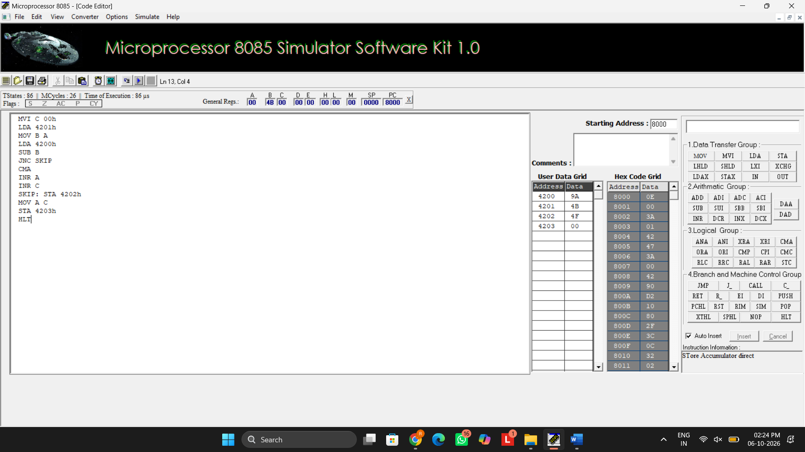

- verify assembly language programs for performing 8-bit multiplication and division using the 8085 microprocessor and check the accuracy of the results.

8 BIT MULTIPLICATION:
LDA 4201h
MOV E A
LDA 4202h
MOV C A
REPEAT: DAD D
DCR C
JNZ REPEAT
SHLD 4203h
HLT
OUTPUT
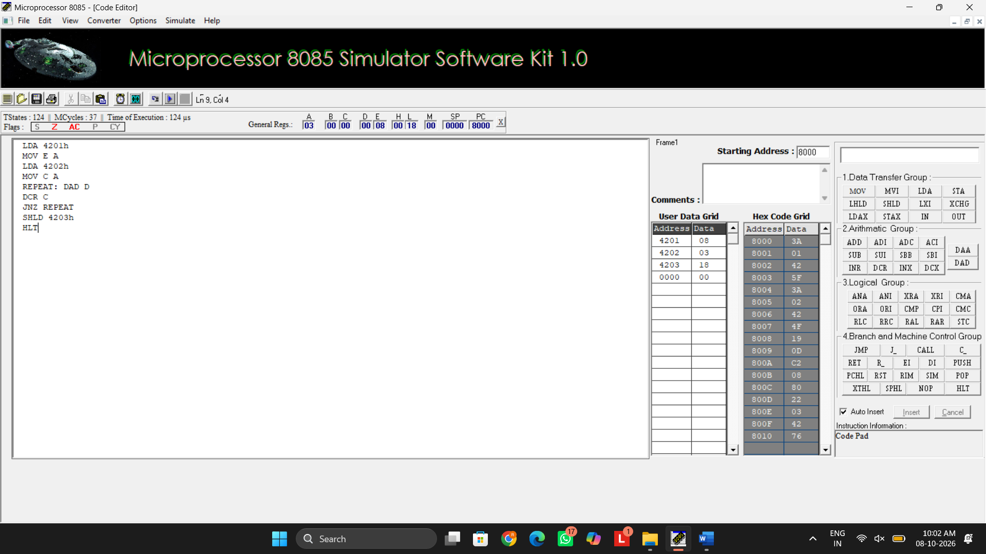
8 BIT DIVISION:
LDA 4201h
MOV B A
LDA 4200h
MVI C 00h
AGAIN: CMP B
JC STORE
SUB B
INR C
JMP AGAIN
STORE: STA 4203
MOV A C
STA 4202h
HLT

OUTPUT
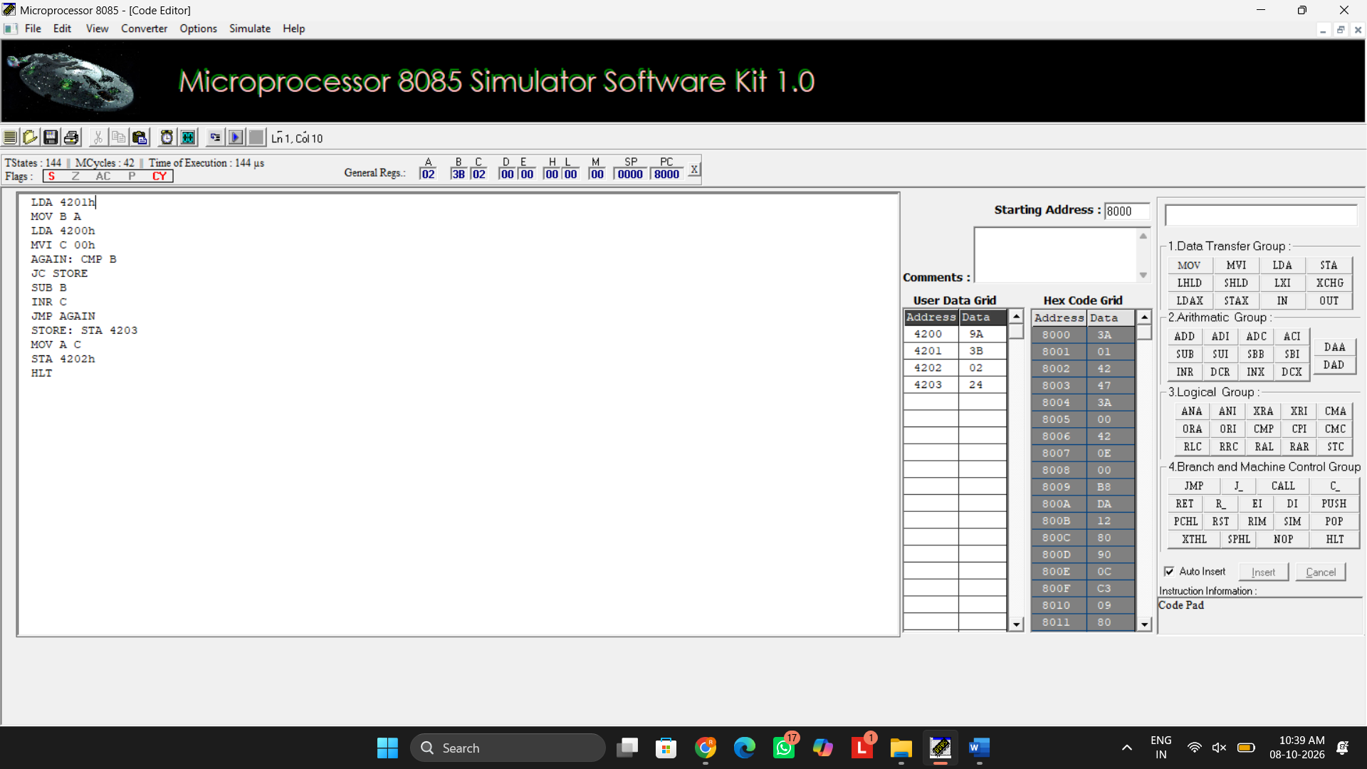

- verify assembly language programs for performing 16-bit addition and subtraction using the 8085 microprocessor and analyze the results obtained.

16 BIT ADDITION

LHLD 4200H
XCHG
LHLD 4202H
DAD D
SHLD 4204H
HLT

OUTPUT
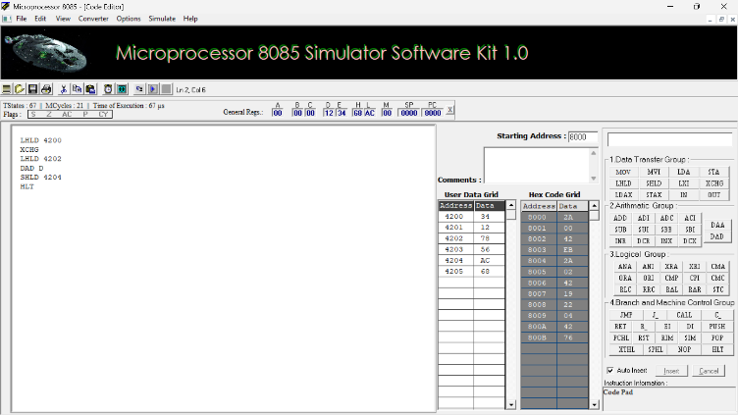
16 BIT SUBRACTION

LHLD 4200H
XCHG
LHLD 4202H
MOV A,L
SUB E
MOV L,A
MOV A,H
SBB D
MOV H,A
SHLD 4204H
HLT
OUTPUT
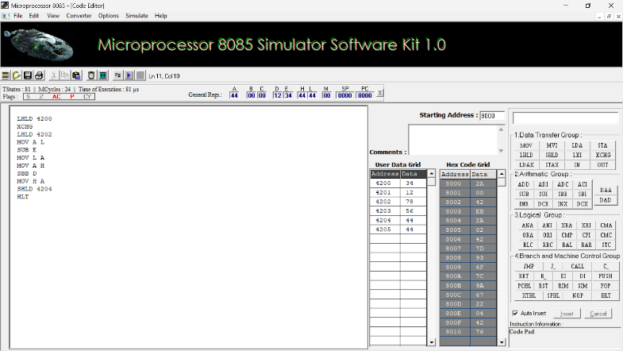

- verify assembly language programs for performing 16-bit multiplication and division using the 8085 microprocessor and validate the results obtained through memory locations.

16 BIT MULTIPLICATION
LHLD 2050H
XCHG
LHLD 2052H
MOV B,H
MOV C,L
LXI H,0000H
SHLD 2056H
MOV A,B
ORA C
JZ STORE
LOOP: DAD D
JNC NEXT
PUSH H
LHLD 2056H
INX H
SHLD 2056H
POP H
NEXT: DCX B
MOV A,B
ORA C
JNZ LOOP
STORE: SHLD 2054H
HLT

OUTPUT
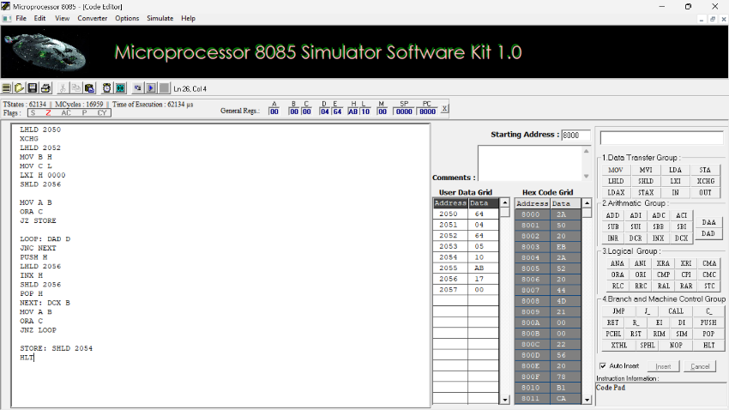

16 BIT DIVISION

LHLD 2050H
XCHG
LHLD 2052H
MOV B,H
MOV C,L
MOV A,B
ORA C
JZ STOP
LXI H,0000H
LOOP: MOV A,D
CMP B
JC DONE
JNZ SUBT
MOV A,E
CMP C
JC DONE
SUBT: MOV A,E
SUB C
MOV E,A
MOV A,D
SBB B
MOV D,A
INX H
JMP LOOP
DONE: SHLD 2054H
XCHG
SHLD 2056H
STOP: HLT

OUTPUT
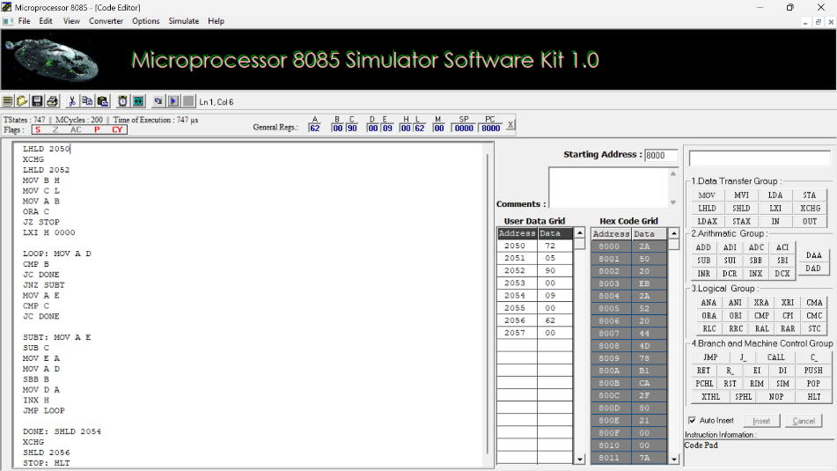

RESULT
Thus, the 8-bit and 16-bit arithmetic operations, including addition, subtraction, multiplication, and division, were successfully developed, executed, and verified using assembly language programs in the 8085 microprocessor simulator.

